Clean Code Principles - Minimize Cyclomatic Complexity
# Source: AI Source: Provided by: [Data Path: Persons Table -> ID Column: 1, Name_En Column: Motasem Essam] -> From: [Chatgpt (GPT‑5 Mini)] on [12/9/2025]
Cyclomatic complexity measures how many independent paths there are through your code (basically, how many decision points like if, for, while, switch).
The higher the complexity, the harder the code is to read, test, and maintain.
Minimizing it leads to simpler, more understandable code.

🔑 Why It Matters
# Source: AI Source: Provided by: [Data Path: Persons Table -> ID Column: 1, Name_En Column: Motasem Essam] -> From: [Chatgpt (GPT‑5 Mini)] on [12/9/2025]
- Easier to read and understand
- Easier to test (fewer test cases needed)
- Reduces bugs
- Encourages smaller, focused functions

❌ Bad Example (High Cyclomatic Complexity)
# Source: AI Source: Provided by: [Data Path: Persons Table -> ID Column: 1, Name_En Column: Motasem Essam] -> From: [Chatgpt (GPT‑5 Mini)] on [12/9/2025]
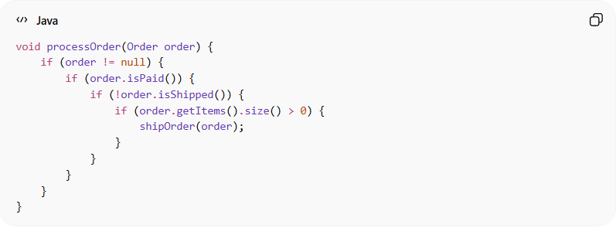
void processOrder(Order order) {
if (order != null) {
if (order.isPaid()) {
if (!order.isShipped()) {
if (order.getItems().size() > 0) {
shipOrder(order);
}
}
}
}
}
👉 Problems:
- Too many nested if statements
- Hard to read and maintain
- Many decision paths → high cyclomatic complexity

✅ Good Example (Simplified, Low Complexity)
# Source: AI Source: Provided by: [Data Path: Persons Table -> ID Column: 1, Name_En Column: Motasem Essam] -> From: [Chatgpt (GPT‑5 Mini)] on [12/9/2025]
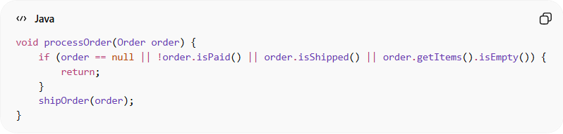
void processOrder(Order order) {
if (order == null || !order.isPaid() || order.isShipped() || order.getItems().isEmpty()) {
return;
}
shipOrder(order);
}
✅ Benefits:
- Fewer nested branches
- Easy to read at a glance
- Single responsibility clear

✅ Another Approach: Extract Functions
# Source: AI Source: Provided by: [Data Path: Persons Table -> ID Column: 1, Name_En Column: Motasem Essam] -> From: [Chatgpt (GPT‑5 Mini)] on [12/9/2025]
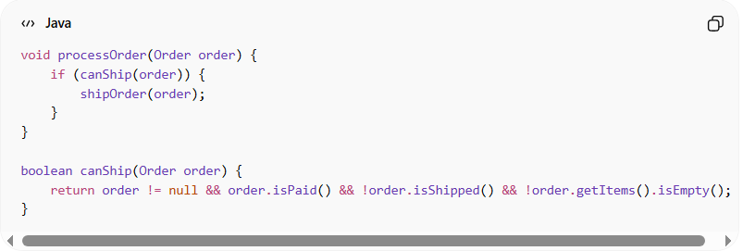
void processOrder(Order order) {
if (canShip(order)) {
shipOrder(order);
}
}

boolean canShip(Order order) {
return order != null && order.isPaid() && !order.isShipped() && !order.getItems().isEmpty();
}
👉 Breaks complex logic into readable, testable pieces

💡 Key Idea
# Source: AI Source: Provided by: [Data Path: Persons Table -> ID Column: 1, Name_En Column: Motasem Essam] -> From: [Chatgpt (GPT‑5 Mini)] on [12/9/2025]
Keep functions simple with minimal decision points.
If complexity grows, extract logic into smaller, descriptive functions.

🚫 Common Mistakes
# Source: AI Source: Provided by: [Data Path: Persons Table -> ID Column: 1, Name_En Column: Motasem Essam] -> From: [Chatgpt (GPT‑5 Mini)] on [12/9/2025]
- Deeply nested if/else statements
- Large functions with multiple responsibilities
- Complex boolean expressions in one line
- Mixing multiple decision-making steps in a single function

🧾 Summary
# Source: AI Source: Provided by: [Data Path: Persons Table -> ID Column: 1, Name_En Column: Motasem Essam] -> From: [Chatgpt (GPT‑5 Mini)] on [12/9/2025]
Minimizing cyclomatic complexity helps you:
- Write simpler, maintainable code
- Make testing easier and more predictable
- Reduce bugs caused by complex logic

